1. Create a table type ZxxxxxxxITSCARRTABTYPE. Mention your empcode in place of xxxxxx.

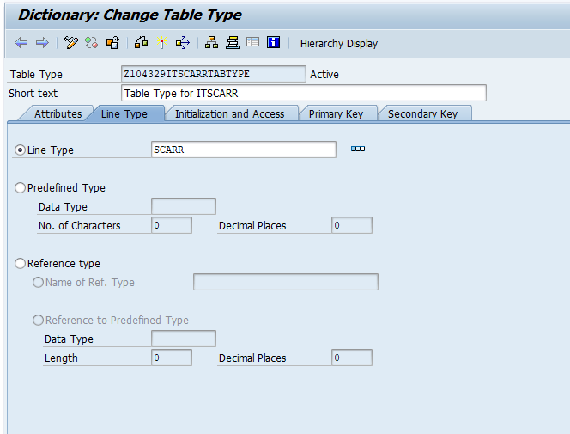

1. Create Function Module. Mention the changing parameter based on the above table type.

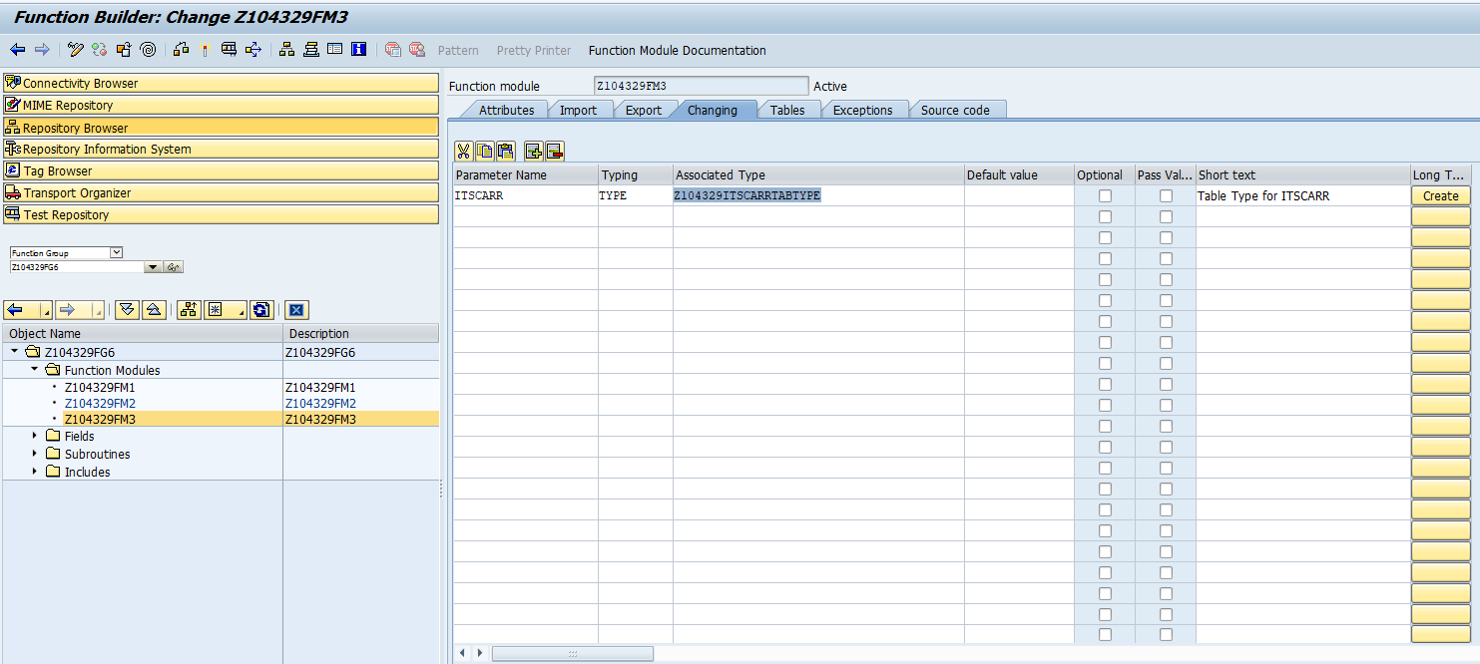

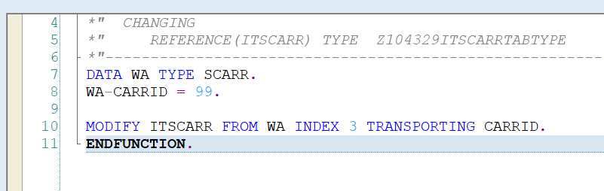

FUNCTION Z104329FM3.  
*\*"----------------------------------------------------------------------*  
*\*"*"Local Interface:*  
*\*"  CHANGING*  
*\*"     REFERENCE(ITSCARR) TYPE  Z104329ITSCARRTABTYPE*  
*\*"----------------------------------------------------------------------*  
DATA WA TYPE SCARR.  
WA-CARRID = 99.  
  
MODIFY ITSCARR FROM WA INDEX 3 TRANSPORTING CARRID.  
ENDFUNCTION.

Call from SE38 program

REPORT Z.  
TYPES : BEGIN OF TYSCARR,  
          MANDT    TYPE MANDT,  
          CARRID   TYPE SCARR-CARRID,  
          CARRNAME TYPE SCARR-CARRNAME,  
          CURRCODE TYPE SCARR-CURRCODE,  
          URL TYPE SCARR-URL,  
        END OF TYSCARR.  
  
DATA ITSCARR1 TYPE TABLE OF TYSCARR.  
DATA WASCARR TYPE TYSCARR.  
  
SELECT MANDT CARRID CARRNAME CURRCODE URL UP TO 5 ROWS  
  FROM SCARR INTO TABLE ITSCARR1.

CL_DEMO_OUTPUT=>DISPLAY( ITSCARR1 ).  
CALL FUNCTION 'Z104329FM3'  
  CHANGING  
    ITSCARR = ITSCARR1.  
  
SKIP 2.  
CL_DEMO_OUTPUT=>DISPLAY( ITSCARR1 ).